Paper Title (Times Roman 14 Bold)

First Author^{1*}
¹First author Affiliation, Country (Times Roman 11: Italic)
E-mail (Times Roman 11)
ORCID iD Link (https://orcid.org/)
Second Author ²
¹Second author Affiliation, Country (Times Roman 11: Italic)
E-mail (Times Roman 11)
ORCID iD Link (https://orcid.org/)
Last Author ³
³Last author Affiliation, Country (Times Roman 11: Italic)
E-mail (Times Roman 11)
ORCID iD Link (https://orcid.org/)

Received: 00/00/0000, Accepted: 00/00/0000, Published: 00/00/0000

ABSTRACT: This template is used to format your paper and style the text. All margins, column widths, line spaces, and text fonts are prescribed, so please do not alter them. Please do not add page numbers, header or footer. After you have formatted your paper according to this guideline, your submission should have the same look as the paper template presented here. The Abstract should be brief, indicating the purpose/significance of the research. Please, do not use symbols, special characters, footnotes, or math in the paper title or abstract. The title and abstract play an important role in the communication of the research. Without a proper title and abstract, most papers may not be read or found (Times Roman 12: Italic)

KEYWORDS: 5 at least (Font : Time New Roman, Size : 12, Normal, interline 1)

____________________________
* Corresponding author:

Introduction (Times Roman 12 template style: Heading 1)
The first line of the first paragraph of each section is not indented, but the others paragraphs are indented by 1 cm. The paper could be written in Arabic/ Tamazight/ English/ French/ Spanish/ German/ Russian/ Italian, Turkish/ Chinese and carefully checked for spelling and grammar before submission. The font of the paper must be Times New Roman (12) as the font for all text with ‘justified’ alignment and single-line spacing. (Times Roman 12 template style: Paragraph first)

Document format
The paper size should be in A4 format.
Authors should submit their original work in MS Word format (.doc/.docx) by using our online paper submission system. (ASJP Plarform)

Elements of the paper
The basic elements of the paper should be listed in the following order: Title of paper, Authors' names and affiliations, Abstract and Keywords, The main body of paper (including figures and tables), Results and discussions, Conclusions, and References. Please do not exceed the page’s margins with tables, text, or figures.

Table and figures
Figures, tables, must be inserted in the text and may not be grouped at the end of the paper. Tables and figures must be numbered, centered and should be placed close after their first reference in the text. Please double check the numbering of these elements before you submit your paper. The table headings should be centred below the tables. Figures and tables not cited in the text should not be presented. The following is an example for Table 1.

Example column 1 | Example column 2 | Example column 3

Table 1. Title of the Table

The figure captions should be below the figures. All figures should be of high quality, legible and numbered according to sequence below each figure. Figure captions and table headings should be sufficient to explain the figure or table without needing to refer to the text.

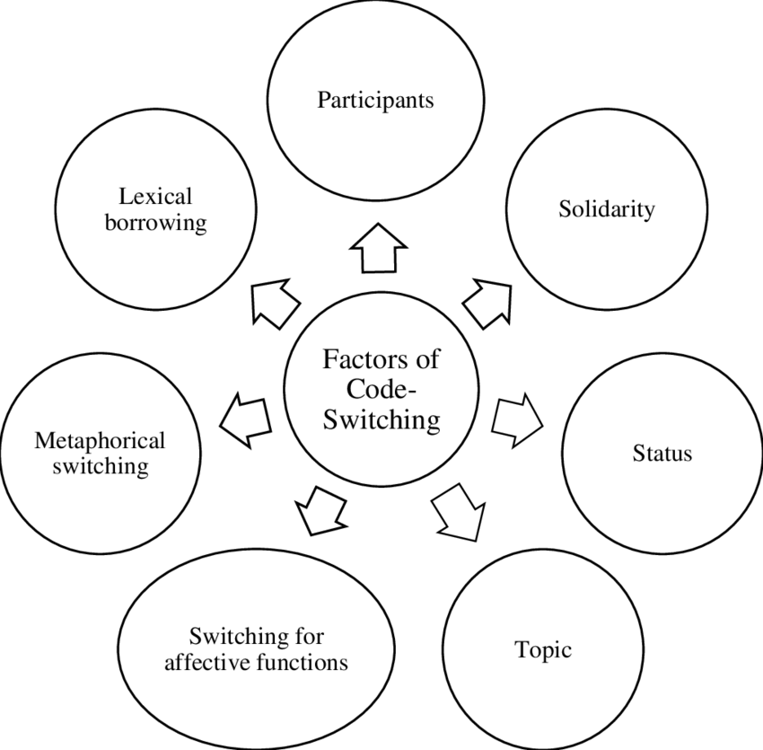
Figure 1. Title of Figure 1 (Template style: Table caption)
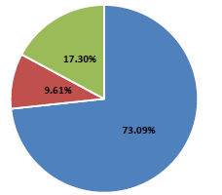
Figure 2. Title of Figure 2

Conclusions
ALTRALANG Journal editors will appreciate it if you would follow these guidelines. If you do not conform to the required formatting, your paper will be return for correction.

Acknowledgments (Optional)
If any, should be placed before the references section without numbering.

References must be in alphabetical order according to the last name of the author in the list of references. In text place the Author's last name, the Year of publication, and Page number inside the parenthesis e.g., (Weinstein 2009, 25). The complete details of the references will appear in the list of references. Unless there are six authors or more give all authors’ names, do not use “et al.” Please include in the References list only those references that were actually cited in the text of the paper. All work that is cited in the text also needs to be in the References. There must be a total agreement between the two. We recommend at least 20 quality references should be cited. References should follow the format in the below examples.

References

The APA style format is the preferred citation style (Time New Roman 12)

Books

- Wells, A. (2009). Metacognitive therapy for anxiety and depression in psychology. Guilford Press.
- Colclough, B., & Colclough, J. (1999). A challenge to change. Thorsons.
- Rosenthal, R., Rosnow, R. L., & Rubin, D. B. (2000). Contrasts and effect sizes in behavioral research: A correlational approach. Cambridge University Press.
- Binstock, R. H., & George, L. K. (Eds.). (1990). Handbook of aging and the social sciences (3rd ed.). Academic Press.
- Eckes, T. (2000). The developmental social psychology of gender. Lawrence Erlbaum Associates. https://prospero.murdoch.edu.au:443/record=b1600608

Book Chapters (Chapter or Article in Edited Book)

- Payne, S. (1999). 'Dangerous and different': Reconstructions of madness in the 1990s and the role of mental health policy. In S. Watson & L. Doyal (Eds.), Engendering social policy (pp. 180-195). Open University Press.

Journal Article

- Kyratsis, A. (2004). Talk and interaction among children and the co-construction of peer groups and peer culture. Annual Review of Anthropology, 33(4), 231-247.
- Vogels, A. G. C., Crone, M. R., Hoekstra, F., & Reijneveld, S. A. (2009). Comparing three short questionnaires to detect psychosocial dysfunction among primary school children: A randomized method. BMC Public Health, 9, 489. https://doi.org/10.1186/1471-2458-9-489
- Ahmann, E., Tuttle, L. J., Saviet, M., & Wright, S. D. (2018). A descriptive review of ADHD coaching research: Implications for college students. Journal of Postsecondary Education and Disability, 31(1), 24-58. https://www.ahead.org/professional-resources/publications/jped/archived-jped/jped-volume-31
- Zhang, B., Cohen, J., Ferrence, R., & Rehm, J. (2006). The impact of tobacco tax cuts on smoking initiation among Canadian young adults. American Journal of Preventive Medicine, 30(6), 474-479.
Theses

- Ryan, J. (2014). The measurement and meaning of coping in psychiatric patients [PhD thesis, Murdoch University]. Murdoch University Research Repository. https://researchrepository.murdoch.edu.au/id/eprint/24254/
- Milnes, G. M. (1998). Adolescent depression: The use of generative instruction to increase rational beliefs and decrease irrational beliefs and depressed mood [Unpublished M.Appl.Psy. thesis]. Murdoch University.
Video
- NRK. (2007, February 26). Medieval helpdesk with English subtitles. [Video]. http://www.youtube.com/watch?v=pQHX-SjgQvQ

Authors' biographies

This should include full name, qualifications and institution(s), including positions of responsibility. In addition, it is also appropriate to discuss your personal history, academic program and/or field placement. The biographical statement may not exceed 100 words.

