Azwel n umagrad (Times Roman 14 Bold)

Ameskar Amezwaru^{1*}
¹Amummi n umeskar amezwaru, Tamurt (Times Roman 11: Italique)
Tamyazant talikeṭrunit (Times Roman 11)
ORCID iD Link (https://orcid.org/)
Ameskar Wis sen²
²Amummi n umeskar wis sen, Tamurt (Times Roman11: Italique)
Tamyazant talikeṭrunit (Times Roman 11)
ORCID iD Link (https://orcid.org/)
Ameskar Aneggaru³
³Amummi n umeskar aneggaru, Tamurt (Times Roman 11: Italique)
Tamyazant talikeṭrunit (Times Roman 11)
ORCID iD Link (https://orcid.org/)

Yettwarmes: 00/00/0000, Yettwaqbel: 00/00/0000, Yettwasufeɣ: 00/00/0000

Title in English (Times Roman 12 Bold)

ABSTRACT: This template is used to format your paper and style the text. All margins, column widths, line spaces, and text fonts are prescribed, so please do not alter them. Please do not add page numbers, header or footer. After you have formatted your paper according to this guideline, your submission should have the same look as the paper template presented here. The Abstract should be brief, indicating the purpose/significance of the research. Please, do not use symbols, special characters, footnotes, or math in the paper title or abstract. The title and abstract play an important role in the communication of the research. Without a proper title and abstract, most papers may not be read or found (Times Roman 12: Italic)

KEYWORDS: 5 at least (Font : Time New Roman, Size : 12, Normal, interline 1)

AGZUL : Tettwasumer-d tmudemt-a i ufares n umagrad-nwen. Timiwa akk, tehriyin, ilmawen d tallunin, timamkin n uḍris d usbiḍen akk. Ur ttbeddalet ara deg-sen. Ur rennit ara azwil n usebter, ixef neɣ aḍar n usebter. Afares n umagrad-nwen ilmend n lewṣayat-a, ilaq ad yettwazen s talɣa i d-yemmuggen day. Agzul ad yili s tewzel, yemmal-d iswi / tixutert n unadi. Ur ssemraset ara izamulen, iwenɣa, timawin n wadda n usebter neɣ n tusnakt deg uzwel neɣ deg ugzul n umagrad. Azwel d ugzul sɛan tamlilt d tameqqrant deg teɣwalt n unadi. Bla azwel d ugzul iwatan, tuget n yimagraden ur ttwaqrayen ara, ur ttwasusemlayen ara. (Times Roman 11: Italique)

AWALEN-IREẒẒAMEN : ma drus 5 n wawalen : …, …, …, …, …, ... (Times Roman 12)

____________________________
* Ameskar amazan :

Tazwert (Times Roman 12, modèle: Titre 1)
Ur netteǧǧa ara ilem deg umezwau n tseddart tamezwarut n yal aferdis seg yiferdisen n umagrad, maca tiseddarin i d-yusin aɣella n tseddart-a yal tict ad as-neǧǧ ilem s wazal n 1 cm deg umezwar-nnes. Amagrad yezmer ad yettwari s Teɛrabt / Tamaziɣt / Taneglizit / Tafransist / Taspenyulit /Talmanit / Tarusit/ Tiṭalit / Taturkit / Tacinwit, ilaq afqad n tuccḍiwin deg wayen yeɛnan tira d tjerrumt qbel n wazan. Tamamekt ara yettwari yes-s umagrad d Times New Roman (12), s usemres n uderrer "justifié" akked tallunt jar yezriren ad tili s yiǧ n uzrir. (Times Roman 12, modèle: premier paragraphe)

Amasal n umagrad
Amasal n umagrad ad yili A4.
Imeskaren ilaq ad aznen leqdicat-nsen inasliyen s umasal MS Word (.doc/.docx) s usemres n unagraw-nneɣ i wazan n yimagraden deg internet (ASJP Platform)

Iferdisen n umagrad
Iferdisen igejdanen n umagrad ilaq ad myezwaren : Azwel, isem n yimeskaren d umummi-nsen, agzul d wawalen ireẓẓamen, talɣa n umagrad (ula tifelwiyin d talɣiwin), igmaḍ d yiskasiyen, tagrayt d yiɣbula. Ilaq ud ttɛeddan ara timiwa n usebter s tfelwiyin, aḍris neɣ isumnen.

Tifelwiyin d talɣiwin
Talɣiwin, tifelwiyin ilaq ad ttwaxedment deg wammas n uḍris ur ttwajmaɛent ara deg taggara n umagrad. Ilaq ad asen-xedment uṭṭunen, ad mmuggent deg wammas n tfercit wa ad rsent srid aɣella n uɣbalu ideg ttwaktint-id deg uḍris. Ilaq afqad n wuṭṭunen n yiferdisen-a qbel azan n umagrad. Izwilen n yiferdisen-a ilaq ad ilin seddu-nsen, ad mmuggen deg wammas. Tifelwiyin d talɣiwin ur d-yettwaktin ara deg uḍris ilaq ur d-ttmuggan ara. Muqqel amedya ɣef tfelwit 1.

Amedya 1 | Amedya 2 | Amedya 3

Tafelwit 1. Azwel n tfelwit

Ilaq ad yili yisem n talɣiwin seddu-nsent. Izwilen ilaq ad ttwarin s tarrayt yelhan, ad banen wa ad ttwafhamen, ad ilin mmeḍfaren seg talɣa tamezwarut al taneggarut. Isem n talɣiwin d yizwal n tfelwiyin ilaq ad ilin banen, ssegzayen-d yal talɣa neɣ tafelwit s wudem yelhan.

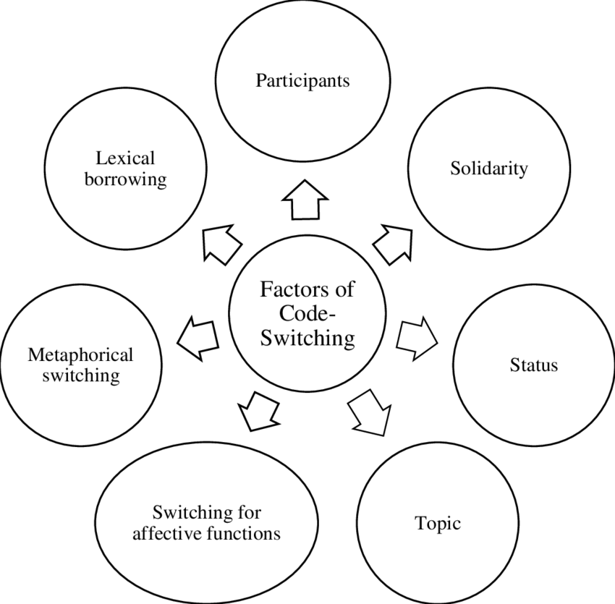
Talɣa 1. Azwel n talɣa 1 (modèle: Légende de la figure)
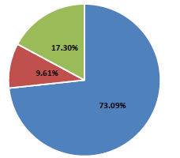
Talɣa 2. Azwel n talɣa 2

Tagrayt
Imsekriyen d yimazzayen n ALTRALANG Journal ssaramen seg-wen ad tḍefrem lewṣayat-a. Ma yella ud tent-teḍfirem ara, ad aken-d-yettwawɛa leqdic-nwen i useɣti n tuccḍiwin.

Asenmer (anufran)
Ma yella, ilaq ad yettwari qbel yiɣbula bla azwil.

Iɣbula : ilaq ad ttwasisemlen ilmend n ugemmay, ilmend n uɣara (lleqmet) n umeskar. Daxel n uḍris, ad nessers aɣara n umeskar, aseggas n usufeɣ d uzwil n usebter jar tacciwin, am umedya (Weinstein, 2009, 25). Ifatusen n yiɣbula ad d-banen akk deg umuɣ n yiɣbula. Umuɣ n yiɣbula ilaq ad yettwasers deg-s yiɣbula i d-yettwaktin deg umagrad amek llan. Iɣbula iseg nerfed tilɣa ilaq ad ten-nessers deg umuɣ yiǧ yiǧ. Ilaq ad ilin yiɣbula n daxel n uḍris d yya n wumuɣ kifkif. Ma tzemrem smerset ugar n 20 n yiɣbula yemxalafen. Ilaq ad ilin yiɣbula ttwarin am yimedyaten i d-yemmuggen ɣer wadd-a.

Iɣbula

Anagraw APA d tarrayt ara yettwaḍefren deg tira n tnebdurin (Time New Roman 12)

Idlisen

- Wells, A. (2009). Metacognitive therapy for anxiety and depression in psychology. Guilford Press.
- Colclough, B., & Colclough, J. (1999). A challenge to change. Thorsons.
- Rosenthal, R., Rosnow, R. L., & Rubin, D. B. (2000). Contrasts and effect sizes in behavioral research: A correlational approach. Cambridge University Press.
- Binstock, R. H., & George, L. K. (Eds.). (1990). Handbook of aging and the social sciences (3rd ed.). Academic Press.
- Eckes, T. (2000). The developmental social psychology of gender. Lawrence Erlbaum Associates. https://prospero.murdoch.edu.au:443/record=b1600608

Ixfawen seg yedlisen (ixef neɣ amagrad deg udlis)

- Payne, S. (1999). 'Dangerous and different': Reconstructions of madness in the 1990s and the role of mental health policy. In S. Watson & L. Doyal (Eds.), Engendering social policy (pp. 180-195). Open University Press.

Imagraden

- Kyratsis, A. (2004). Talk and interaction among children and the co-construction of peer groups and peer culture. Annual Review of Anthropology, 33(4), 231-247.
- Vogels, A. G. C., Crone, M. R., Hoekstra, F., & Reijneveld, S. A. (2009). Comparing three short questionnaires to detect psychosocial dysfunction among primary school children: A randomized method. BMC Public Health, 9, 489. https://doi.org/10.1186/1471-2458-9-489
- Ahmann, E., Tuttle, L. J., Saviet, M., & Wright, S. D. (2018). A descriptive review of ADHD coaching research: Implications for college students. Journal of Postsecondary Education and Disability, 31(1), 24-58. https://www.ahead.org/professional-resources/publications/jped/archived-jped/jped-volume-31
- Zhang, B., Cohen, J., Ferrence, R., & Rehm, J. (2006). The impact of tobacco tax cuts on smoking initiation among Canadian young adults. American Journal of Preventive Medicine, 30(6), 474-479.

Tisersiyin

- Ryan, J. (2014). The measurement and meaning of coping in psychiatric patients [PhD thesis, Murdoch University]. Murdoch University Research Repository. https://researchrepository.murdoch.edu.au/id/eprint/24254/
- Milnes, G. M. (1998). Adolescent depression: The use of generative instruction to increase rational beliefs and decrease irrational beliefs and depressed mood [Unpublished M.Appl.Psy. thesis]. Murdoch University.
Taẓrawit

- NRK. (2007, February 26). Medieval helpdesk with English subtitles. [Video]. http://www.youtube.com/watch?v=pQHX-SjgQvQ
Taseknudert n yimeskaren

Ad d-temmeslay ɣef yisem-nsen, leqdicat-nsen, tisuda ideg xedmen, ansaten i ṭṭfen. Daɣen ad temmeslay ɣef umezruy n yiman-nsen, ahil akadimi, d unnar ideg ssfayden. Taseknudert ud tettɛedda ara 100 n wawalen.

